**Chapter 1: Introduction to Computer Systems**

**1.1 Introduction to computers**

A computer is an electronic device that takes input or output such as numbers, text, sound, image, animations, video, etc., processes it, and converts it into meaningful information that could be understood, presenting the changed input (processed input) as output.

Computer is a device that transforms data into meaningful information. It processes the input according to the set of instructions provided to it by the user and gives the desired output quickly. A Computer can perform the following set of functions:

1. a)Accept data
2. b)Store data
3. c)Process data as desired
4. d)Retrieve the stored data as and when required
5. e)Print the result in desired format.

**Data and Information:**

**Data:** It is the term used for raw facts and figures fed into the computer and along with the set of instructions which enables the computer to convert this raw data into refined and useful information.

**Information:** Data represented in useful and meaningful form is information.

**1.2 Architecture of Digital Computer**

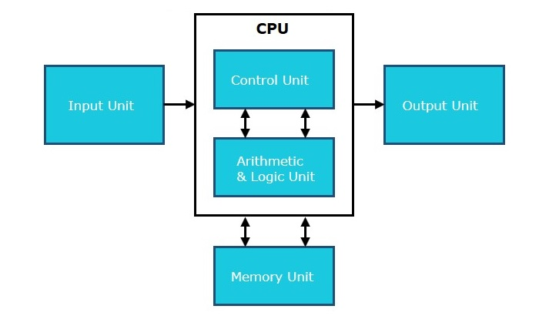

A digital computer can be defined as a programmable machine which reads the binary data passed as instructions, processes this binary data, and displays a calculated digital output. Therefore, Digital computers are those that work on digital data.

**1.2.1 Input Unit :**The input unit consists of input devices that are attached to the computer. These devices take input and convert it into binary language that the computer understands. Some of the common input devices are keyboard, mouse, joystick, scanner etc.

**1.2.2 Central Processing Unit (CPU)** : Once the information is entered into the computer by the input device, the processor processes it. The CPU is called the brain of the computer because it is the control center of the computer. It first fetches instructions from memory and then interprets them so as to know what is to be done. If required, data is fetched from memory or input device. Thereafter the CPU executes or performs the required computation and then either stores the output or displays on the output device. The CPU has three main components which are responsible for different functions – Arithmetic Logic Unit (ALU), Control Unit (CU) and Memory registers

**1.2.2.1 Arithmetic and Logic Unit (ALU) :** The ALU, as its name suggests performs mathematical calculations and makes logical decisions. Arithmetic calculations include addition, subtraction, multiplication and division. Logical decisions involve comparison of two data items to see which one is larger or smaller or equal.

**1.2.2.2 Control Unit :** The Control unit coordinates and controls the data flow in and out of CPU and also controls all the operations of ALU, memory registers and also input/output units. It is also responsible for carrying out all the instructions stored in the program. It decodes the fetched instruction, interprets it and sends control signals to input/output devices until the required operation is done properly by ALU and memory.

**1.2.3 Memory Registers :** A register is a temporary unit of memory in the CPU. These are used to store the data which is directly used by the processor. Registers can be of different sizes(16 bit, 32 bit, 64 bit and so on) and each register inside the CPU has a specific function like storing data, storing an instruction, storing address of a location in memory etc. The user registers can be used by an assembly language programmer for storing operands, intermediate results etc. Accumulator (ACC) is the main register in the ALU and contains one of the operands of an operation to be performed in the ALU.

**1.2.4 Memory :** Memory attached to the CPU is used for storage of data and instructions and is called internal memory. The internal memory is divided into many storage locations, each of which can store data or instructions. Each memory location is of the same size and has an address.

**1.3 Central Processing Unit**

Central Processing Unit (CPU) consists of the following features −

* CPU is considered as the brain of the computer.
* CPU performs all types of data processing operations.
* It stores data, intermediate results, and instructions (program).
* It controls the operation of all parts of the computer.

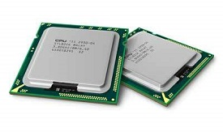

The CPU itself has the following three components.

* Memory or Storage Unit
* Control Unit
* ALU(Arithmetic Logic Unit)



**1.3.1 Memory or Storage Unit**

This unit can store instructions, data, and intermediate results. This unit supplies information to other units of the computer when needed. It is also known as the internal storage unit or the main memory or the primary storage or Random Access Memory (RAM).

Its size affects speed, power, and capability. Primary memory and secondary memory are two types of memories in the computer. Functions of the memory unit are −

* It stores all the data and the instructions required for processing.
* It stores intermediate results of processing.
* It stores the final results of processing before these results are released to an output device.
* All inputs and outputs are transmitted through the main memory.

**1.3.2 Control Unit**

This unit controls the operations of all parts of the computer but does not carry out any actual data processing operations.

**Functions of this unit are −**

* It is responsible for controlling the transfer of data and instructions among other units of a computer.
* It manages and coordinates all the units of the computer.
* It obtains the instructions from the memory, interprets them, and directs the operation of the computer.
* It communicates with Input/Output devices for transfer of data or results from storage.
* It does not process or store data.

**1.3.3 ALU (Arithmetic Logic Unit)**

This unit consists of two subsections namely,

* Arithmetic Section
* Logic Section

**1.3.3.1 Arithmetic Section**

Function of the arithmetic section is to perform arithmetic operations like addition, subtraction, multiplication, and division. All complex operations are done by making repetitive use of the above operations.

**1.3.3.2 Logic Section**

Function of the logic section is to perform logic operations such as comparing, selecting, matching, and merging of data.

**1.4 Computer Memory**

Computer memory is just like the human brain. It is used to store data/information and instructions. It is a data storage unit or a data storage device where data is to be processed and instructions required for processing are stored. It can store both the input and output can be stored here.

**1.5 Primary Memory**

Primary memory is a segment of computer memory that can be accessed directly by the processor. In a hierarchy of memory, primary memory has access time less than secondary memory and greater than cache memory. Generally, primary memory has a storage capacity lesser than secondary memory and greater than cache memory.

It is also known as the main memory of the computer system. It is used to store data and programs or instructions during computer operations. It uses semiconductor technology and hence is commonly called semiconductor memory. Primary memory is of two types

**Classification of Primary Memory**

Primary memory can be broadly classified into two parts:

1. Read-Only Memory (ROM)
2. Random Access Memory (RAM)
3. 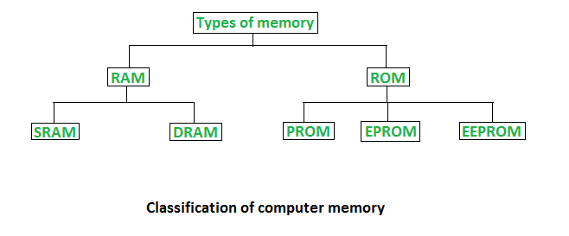

**1.5.1 Read-Only Memory:**Any data which need not be altered are stored in ROM. ROM includes those programs which run on booting of the system (known as a bootstrap program that initializes OS) along with data like algorithms required by OS. Anything stored in ROM cannot be altered or changed.

**Types of ROM:**

ROM can be broadly classified into 4 types based on their behavior:

**PROM:** Programmable ROM can be modified once by the user. The user buys a blank PROM and writes the desired content but once written content cannot be altered.

**EPROM:** Erasable and Programmable ROM Content can be changed by erasing the initial content which can be done by exposing EPROM to UV radiation. This exposure to ultraviolet light dissipates the charge on ROM and content can be rewritten on it.

**EEPROM:** Electrically Erasable and Programmable ROM Content can be changed by erasing the initial content which could be easily erased electrically. However, one byte can be erased at a time instead of being deleted in one go. Hence, reprogramming of EEPROM is a slow process.

**1.5.2 Random Access Memory**

Any process in the system which needs to be executed is loaded in RAM which is processed by the CPU as per Instructions in the program. Like if we click on applications like Browser, firstly browser code will be loaded by the Operating system into the RAM after which the CPU will execute and open up the Browser.

**Types of RAM:**

RAM can be broadly classified into SRAM (Static RAM) and DRAM (Dynamic RAM) based on their behavior:

* **DRAM:** Dynamic RAM or DRAM needs to periodically refresh in a few milliseconds to retain data. DRAM is made up of capacitors and transistors and electric charge leaks from capacitors and DRAM needs to be charged periodically. DRAM is widely used in home PCs and servers as it is cheaper than SRAM.
* **SRAM:** Static RAM or SRAM keeps the data as long as power is supplied to the system. SRAM uses Sequential circuits like a flip-flop to store a bit and hence need not be periodically refreshed. SRAM is expensive and hence only used where speed is the utmost priority.

**1.6 Secondary Memory**

Primary memory has limited storage capacity and is volatile. Secondary memory overcomes this limitation by providing permanent storage of data and in bulk quantity. Secondary memory is also termed external memory and refers to the various storage media on which a computer can store data and programs. The Secondary storage media can be fixed or removable. Fixed Storage media is an internal storage medium like a hard disk that is fixed inside the computer. A storage medium that is portable and can be taken outside the computer is termed removable storage media.

Let us look at some of the secondary memory devices available.

**Hard Disk Drive**

Hard disk drive is made up of a series of circular disks called platters arranged one over the other almost ½ inches apart around a spindle. Disks are made of non-magnetic material like aluminum alloy and coated with 10-20 nm of magnetic material.

Standard diameter of these disks is 14 inches and they rotate with speeds varying from 4200 rpm (rotations per minute) for personal computers to 15000 rpm for servers. Data is stored by magnetizing or demagnetizing the magnetic coating. A magnetic reader arm is used to read data from and write data to the disks. A typical modern HDD has capacity in terabytes (TB).

**CD Drive**

CD stands for Compact Disk. CDs are circular disks that use optical rays, usually lasers, to read and write data. They are very cheap as you can get 700 MB of storage space for less than a dollar. CDs are inserted in CD drives built into the CPU cabinet. They are portable as you can eject the drive, remove the CD and carry it with you. There are three types of CDs −

* CD-ROM (Compact Disk – Read Only Memory) − The data on these CDs are recorded by the manufacturer. Proprietary Software, audio or video are released on CD-ROMs.
* CD-R (Compact Disk – Recordable) − Data can be written by the user once on the CD-R. It cannot be deleted or modified later.
* CD-RW (Compact Disk – Rewritable) − Data can be written and deleted on these optical disks again and again.

**DVD Drive**

DVD stands for Digital Video Display. DVDs are optical devices that can store 15 times the data held by CDs. They are usually used to store rich multimedia files that need high storage capacity. DVDs also come in three varieties – read only, recordable and rewritable.

**Pen Drive**

Pen drive is a portable memory device that uses solid state memory rather than magnetic fields or lasers to record data. It uses a technology similar to RAM, except that it is nonvolatile. It is also called USB drive, key drive or flash memory.

**Blu Ray Disk**

Blu Ray Disk (BD) is an optical storage media used to store high definition (HD) video and other multimedia files. BD uses a shorter wavelength laser as compared to CD/DVD. This enables the writing arm to focus more tightly on the disk and hence pack in more data. BDs can store up to 128 GB data.

**1.7 Input Devices**

Following are some of the important input devices which are used in a computer −

* Keyboard
* Mouse
* Joy Stick
* Light pen
* Track Ball
* Scanner
* Graphic Tablet
* Microphone
* Magnetic Ink Card Reader(MICR)
* Optical Character Reader(OCR)
* Bar Code Reader
* Optical Mark Reader(OMR)

**Keyboard**

Keyboard is the most common and very popular input device which helps to input data to the computer. The layout of the keyboard is like that of traditional typewriter, although there are some additional keys provided for performing additional functions.

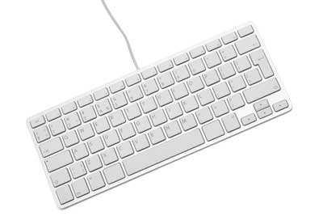

Keyboards are of two sizes 84 keys or 101/102 keys, but now keyboards with 104 keys or 108 keys are also available for Windows and Internet.

The keys on the keyboard are as follows −

| **S.No** | **Keys & Description** |
| --- | --- |
| 1 | Typing Keys  These keys include the letter keys (A-Z) and digit keys (09) which generally give the same layout as that of typewriters. |
| 2 | Numeric Keypad  It is used to enter the numeric data or cursor movement. Generally, it consists of a set of 17 keys that are laid out in the same configuration used by most adding machines and calculators. |
| 3 | Function Keys  The twelve function keys are present on the keyboard which are arranged in a row at the top of the keyboard. Each function key has a unique meaning and is used for some specific purpose. |
| 4 | Control keys  These keys provide cursor and screen control. It includes four directional arrow keys. Control keys also include Home, End, Insert, Delete, Page Up, Page Down, Control(Ctrl), Alternate(Alt), Escape(Esc). |
| 5 | Special Purpose Keys  Keyboard also contains some special purpose keys such as Enter, Shift, Caps Lock, Num Lock, Space bar, Tab, and Print Screen. |

**Mouse**

Mouse is the most popular pointing device. It is a very famous cursor-control device having a small palm size box with a round ball at its base, which senses the movement of the mouse and sends corresponding signals to the CPU when the mouse buttons are pressed.

Generally, it has two buttons called the left and the right button and a wheel is present between the buttons. A mouse can be used to control the position of the cursor on the screen, but it cannot be used to enter text into the computer.

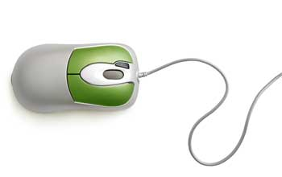

Advantages

* Easy to use
* Not very expensive
* Moves the cursor faster than the arrow keys of the keyboard.

**Joystick**

Joystick is also a pointing device, which is used to move the cursor position on a monitor screen. It is a stick having a spherical ball at its both lower and upper ends. The lower spherical ball moves in a socket. The joystick can be moved in all four directions.

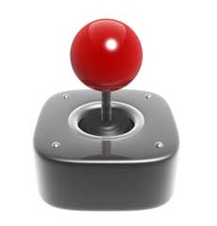

The function of the joystick is similar to that of a mouse. It is mainly used in Computer Aided Designing (CAD) and playing computer games.

**Light Pen**

Light pen is a pointing device similar to a pen. It is used to select a displayed menu item or draw pictures on the monitor screen. It consists of a photocell and an optical system placed in a small tube.

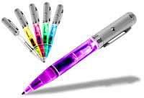

When the tip of a light pen is moved over the monitor screen and the pen button is pressed, its photocell sensing element detects the screen location and sends the corresponding signal to the CPU.

**Track Ball**

Track ball is an input device that is mostly used in notebook or laptop computer, instead of a mouse. This is a ball which is half inserted and by moving fingers on the ball, the pointer can be moved.

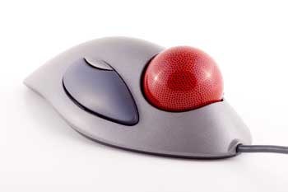

Since the whole device is not moved, a track ball requires less space than a mouse. A track ball comes in various shapes like a ball, a button, or a square.

**Scanner**

Scanner is an input device, which works more like a photocopy machine. It is used when some information is available on paper and it is to be transferred to the hard disk of the computer for further manipulation.

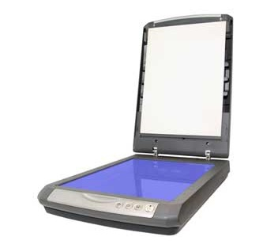

Scanner captures images from the source which are then converted into a digital form that can be stored on the disk. These images can be edited before they are printed.

**Digitizer**

Digitizer is an input device which converts analog information into digital form. Digitizer can convert a signal from the television or camera into a series of numbers that could be stored in a computer. They can be used by the computer to create a picture of whatever the camera had been pointed at.

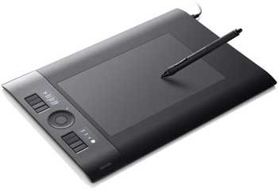

Digitizer is also known as Tablet or Graphics Tablet as it converts graphics and pictorial data into binary inputs. A graphic tablet as digitizer is used for fine works of drawing and image manipulation applications.

**Microphone**

Microphone is an input device to input sound that is then stored in a digital form.

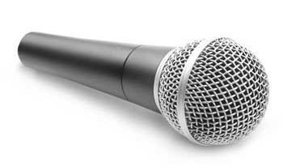

The microphone is used for various applications such as adding sound to a multimedia presentation or for mixing music.

**Magnetic Ink Card Reader (MICR)**

MICR input device is generally used in banks as there are large number of cheques to be processed every day. The bank's code number and cheque number are printed on the cheques with a special type of ink that contains particles of magnetic material that are machine readable.

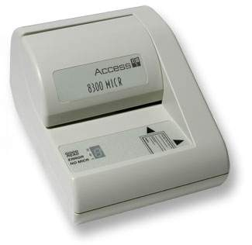

This reading process is called Magnetic Ink Character Recognition (MICR). The main advantages of MICR is that it is fast and less error prone.

**Optical Character Reader (OCR)**

OCR is an input device used to read a printed text.

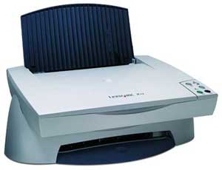

OCR scans the text optically, character by character, converts them into a machine readable code, and stores the text on the system memory.

**Bar Code Readers**

Bar Code Reader is a device used for reading bar coded data (data in the form of light and dark lines). Bar coded data is generally used in labelling goods, numbering the books, etc. It may be a handheld scanner or may be embedded in a stationary scanner.

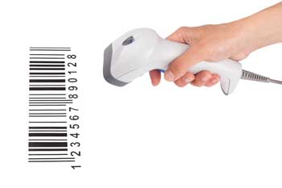

Bar Code Reader scans a bar code image, converts it into an alphanumeric value, which is then fed to the computer that the bar code reader is connected to.

**Optical Mark Reader (OMR)**

OMR is a special type of optical scanner used to recognize the type of mark made by pen or pencil. It is used where one out of a few alternatives is to be selected and marked.

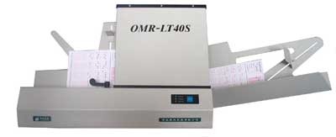

It is specially used for checking the answer sheets of examinations having multiple choice questions.

**1.8 Output Devices**

Any peripheral that accepts data from a computer and prints, projects, or reproduces it is known as an output device. The output may be audio, video, hard copy – printed paper, etc. Output devices convert the computer data to human understandable form.

We give input to the computer using input devices and the computer performs operations on the data and displays the output to the user using the output device.

**Output Devices**

The various output devices are:

**1. Monitor**

A computer’s principal output device is a monitor, often known as a Visual Display Unit (VDU). It displays the processed data like text, images, videos, audios, etc. It makes images by arranging microscopic dots in a rectangular pattern, known as pixels. The sharpness of an image is determined by the number of pixels.

Fig:Monitor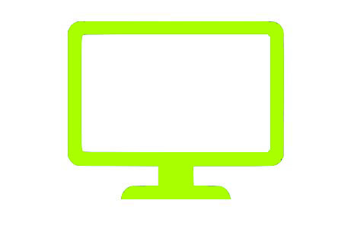

**2. Printer**

Printers are information output devices that allow you to print data on paper. Or in other words, it is an output device that creates a hard copy of the processed data or information.

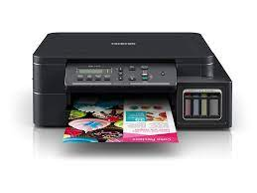

**3. Plotter**

A plotter is a device that prints high-quality graphics in a variety of color formats. It works in a similar way to a printer, although it has more advanced features. It is used to print large maps, architectural drawings, large-format printing, and create pictures, 3D postcards, advertising signs, charts, and various designs of the internal structure of building machines, as well as create pictures, 3D postcards, advertising signs, charts, and various designs of the internal structure of building machines.

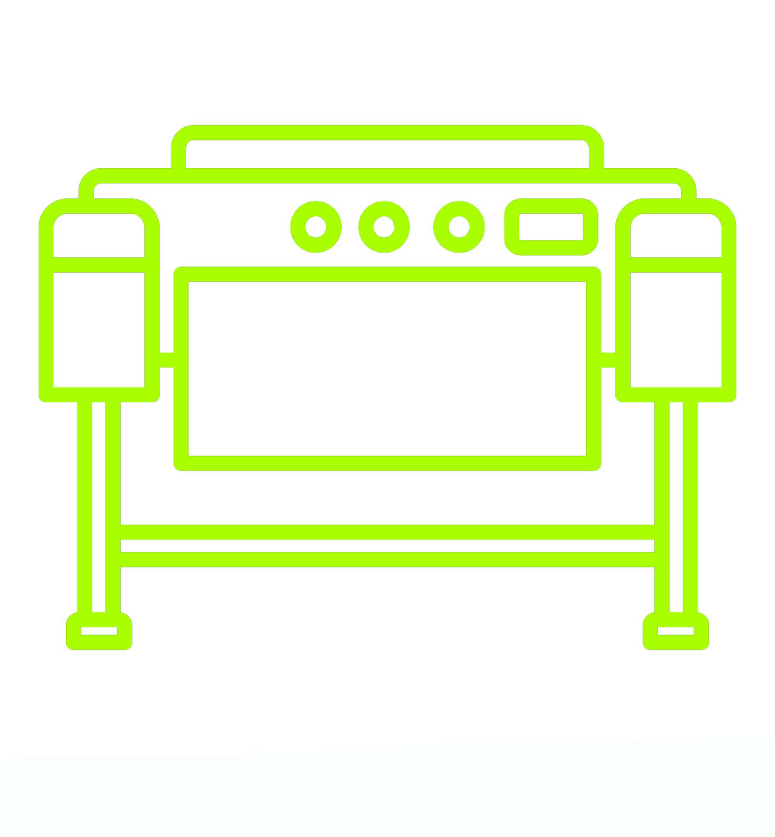

**4. Projector**

A projector is a device that allows users to project their output onto a large area, such as a screen or a wall. It can be used to project the output of a computer and other devices onto a screen. It magnifies texts, photos, and movies using light and lenses. As a result, it’s an excellent output device for giving presentations or teaching big groups of people.

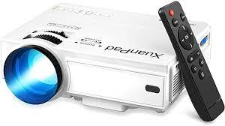

**5. Speakers**

Speakers are connected to computers to allow sound to be output. For the working of speakers, sound cards are required. From simple two-speaker output devices to surround-sound multi-channel sets, speakers come in a variety of shapes and sizes. They take audio input from the computer’s sound card and output sound waves as audio output.

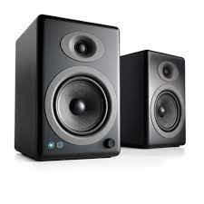

**6. Headphones**

To hear the sound, use earbuds with your PC, laptop, or smartphone. It enables you to hear the sound without causing any inconvenience to others. To translate electronic signals into sounds without causing inconvenience to others. They can be wired or wireless and can be connected to computers, laptops, mobile phones, etc. They are connected with the devices via Bluetooth.



**7. Sound Card**

Sound cards are computer output devices that are inserted into the computer. A sound card, either external or internal, is required to produce sound on any computer (built-in). An external sound card enables better overall sound generation and is required for wide and clear sound recording, as well as sound without noise and interference.

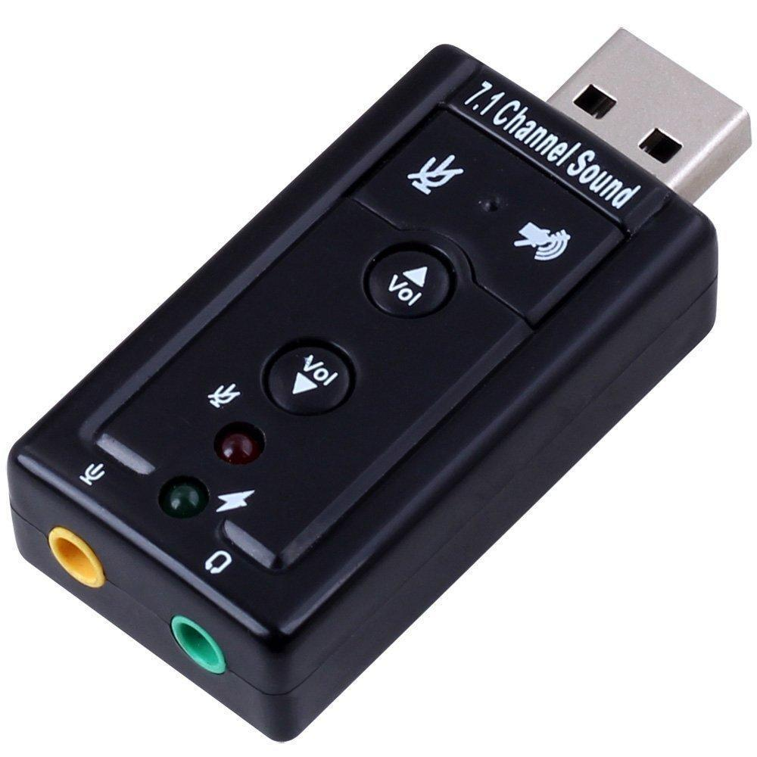

**8. Video Card**

An extension card via which a computer can transfer graphical data to a video display device like a TV, projector, or monitor. It processes photos and video, as well as other functions that the CPU generally does. As they have a good processing capability and video RAM, Gamers utilize video cards.

**9. GPS**

The Global Positioning System (GPS) is a radio-based satellite navigation system that uses radio signals to pinpoint a specific position. The sender sends a radio signal to satellites, which collect data such as time, location, speed, and other variables and deliver it to the reception computer for analysis. Because this processed data can be evaluated to obtain information, it is considered as an output device.

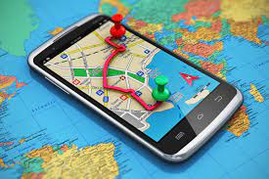

**1.9 Computer Software**

Software is a set of programs, which is designed to perform a well-defined function. A program is a sequence of instructions written to solve a particular problem.

There are two types of software −

* System Software
* Application Software

**1.10 System Software**

The system software is a collection of programs designed to operate, control, and extend the processing capabilities of the computer itself. System software is generally prepared by the computer manufacturers. These software products comprise of programs written in low-level languages, which interact with the hardware at a very basic level. System software serves as the interface between the hardware and the end users.

Some examples of system software are Operating System, Compilers, Interpreter, Assemblers, etc.

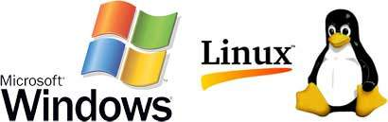

Here is a list of some of the most prominent features of a system software −

* Close to the system
* Fast in speed
* Difficult to design
* Difficult to understand
* Less interactive
* Smaller in size
* Difficult to manipulate
* Generally written in low-level language

**1.11 Application Software**

Application software products are designed to satisfy a particular need of a particular environment. All software applications prepared in the computer lab can come under the category of Application software.

Application software may consist of a single program, such as Microsoft's notepad for writing and editing a simple text. It may also consist of a collection of programs, often called a software package, which work together to accomplish a task, such as a spreadsheet package.

Examples of Application software are the following −

* Payroll Software
* Student Record Software
* Inventory Management Software
* Income Tax Software
* Railways Reservation Software
* Microsoft Office Suite Software
* Microsoft Word
* Microsoft Excel
* Microsoft PowerPoint

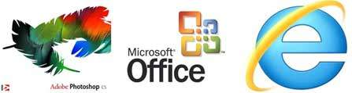

Features of application software are as follows −

* Close to the user
* Easy to design
* More interactive
* Slow in speed
* Generally written in high-level language
* Easy to understand
* Easy to manipulate and use
* Bigger in size and requires large storage space

**1.12 Operating System**

An operating system (OS) is a collection of software that manages computer hardware resources and provides common services for computer programs. The operating system is a vital component of the system software in a computer system. This tutorial will take you through step by step approach while learning Operating System concepts.

Applications of Operating System

Following are some of the important activities that an Operating System performs −

* Security − By means of password and similar other techniques, it prevents unauthorized access to programs and data.
* Control over system performance − Recording delays between request for a service and response from the system.
* Job accounting − Keeping track of time and resources used by various jobs and users.
* Error detecting aids − Production of dumps, traces, error messages, and other debugging and error detecting aids.
* Coordination between other softwares and users − Coordination and assignment of compilers, interpreters, assemblers and other software to the various users of the computer systems.

**Functions of Operating System**

Following are some of important functions of an operating System.

* Memory Management
* Processor Management
* Device Management
* File Management
* Security
* Control over system performance
* Job accounting
* Error detecting aids
* Coordination between other software and users

**Types of Operating System (OS)**

Following are the popular types of OS (Operating System):

Batch Operating System

Multitasking/Time Sharing OS

Multiprocessing OS

Real Time OS

Distributed OS

Network OS

Mobile OS

**Batch Operating System**

Some computer processes are very lengthy and time-consuming. To speed the same process, a job with a similar type of needs are batched together and run as a group.

The user of a batch operating system never directly interacts with the computer. In this type of OS, every user prepares his or her job on an offline device like a punch card and submit it to the computer operator.

**Multi-Tasking/Time-sharing Operating systems**

Time-sharing operating system enables people located at a different terminal(shell) to use a single computer system at the same time. The processor time (CPU) which is shared among multiple users is termed as time sharing.

**Real time OS**

A real time operating system time interval to process and respond to inputs is very small. Examples: Military Software Systems, Space Software Systems are the Real time OS example.

**Distributed Operating System**

Distributed systems use many processors located in different machines to provide very fast computation to its users.

**Network Operating System**

Network Operating System runs on a server. It provides the capability to serve to manage data, user, groups, security, application, and other networking functions.

**Mobile OS**

Mobile operating systems are those OS which are especially designed to power smartphones, tablets, and wearables devices.

**1.13 Generation of Computer**

Generation in computer terminology is a change in technology a computer is/was being used. Initially, the generation term was used to distinguish between varying hardware technologies. Nowadays, generation includes both hardware and software, which together make up an entire computer system.

There are five computer generations known till date. Each generation has been discussed in detail along with their time period and characteristics. In the following table, approximate dates against each generation have been mentioned, which are normally accepted.

Following are the main five generations of computers.

| **S.No** | **Generation & Description** |
| --- | --- |
| 1 | [First Generation](https://www.tutorialspoint.com/computer_fundamentals/computer_first_generation.htm)  The period of the first generation: 1946-1959. Vacuum tube based. |
| 2 | [Second Generation](https://www.tutorialspoint.com/computer_fundamentals/computer_second_generation.htm)  The period of the second generation: 1959-1965. Transistor based. |
| 3 | [Third Generation](https://www.tutorialspoint.com/computer_fundamentals/computer_third_generation.htm)  The period of the third generation: 1965-1971. Integrated Circuit based. |
| 4 | [Fourth Generation](https://www.tutorialspoint.com/computer_fundamentals/computer_fourth_generation.htm)  The period of the fourth generation: 1971-1980. VLSI microprocessor based. |
| 5 | [Fifth Generation](https://www.tutorialspoint.com/computer_fundamentals/computer_fifth_generation.htm)  The period of fifth generation: 1980-onwards. ULSI microprocessor based. |

**1.14 Applications of Computer**

Computers play a role in every field of life. They are used in homes, business, educational institutions, research organizations, medical field, government offices, entertainment, etc.

**Home**

Computers are used at homes for several purposes like online bill payment, watching movies or shows at home, home tutoring, social media access, playing games, internet access, etc. They provide communication through electronic mail. They help to avail work from home facility for corporate employees. Computers help the student community to avail online educational support.

**Medical Field**

Computers are used in hospitals to maintain a database of patients’ history, diagnosis, X-rays, live monitoring of patients, etc. Surgeons nowadays use robotic surgical devices to perform delicate operations, and conduct surgeries remotely. Virtual reality technologies are also used for training purposes. It also helps to monitor the fetus inside the mother’s womb.

**Entertainment**

Computers help to watch movies online, play games online; act as a virtual entertainer in playing games, listening to music, etc. MIDI instruments greatly help people in the entertainment industry in recording music with artificial instruments. Videos can be fed from computers to full screen televisions. Photo editors are available with fabulous features.

**Industry**

Computers are used to perform several tasks in industries like managing inventory, designing purpose, creating virtual sample products, interior designing, video conferencing, etc. Online marketing has seen a great revolution in its ability to sell various products to inaccessible corners like interior or rural areas. Stock markets have seen phenomenal participation from different levels of people through the use of computers.

**Education**

Computers are used in education sector through online classes, online examinations, referring e-books, online tutoring, etc. They help in increased use of audio-visual aids in the education field.

**Government**

In government sectors, computers are used in data processing, maintaining a database of citizens and supporting a paperless environment. The country’s defense organizations have greatly benefitted from computers in their use for missile development, satellites, rocket launches, etc.

**Banking**

In the banking sector, computers are used to store details of customers and conduct transactions, such as withdrawal and deposit of money through ATMs. Banks have reduced manual errors and expenses to a great extent through extensive use of computers.

**Business**

Nowadays, computers are totally integrated into business. The main objective of business is transaction processing, which involves transactions with suppliers, employees or customers. Computers can make these transactions easy and accurate. People can analyze investments, sales, expenses, markets and other aspects of business using computers.

**Training**

Many organizations use computer-based training to train their employees, to save money and improve performance. Video conferencing through computers allows saving of time and travelling costs by being able to connect people in various locations.

**Arts**

Computers are extensively used in dance, photography, arts and culture. The fluid movement of dance can be shown live via animation. Photos can be digitized using computers.

**Science and Engineering**

Computers with high performance are used to stimulate dynamic process in Science and Engineering. Supercomputers have numerous applications in area of Research and Development (R&D). Topographic images can be created through computers. Scientists use computers to plot and analyze data to have a better understanding of earthquakes.